Retirement Cars
You have perhaps read my "Car Crazy" article but the following stories are about the 13 vehicles that we have owned since retiring in 2002. It may seem that we are wealthy, but all thirteen together cost less than a new compact car. Since we made a profit on most of these vehicles, we are still ahead $600 with two of the nicest cars in the garage!
Four Buick Roadmaster "Woodies"
When we retired from Austria in October, 2002, we sold the two vehicles that we owned there and purchased a 1992 Buick Roadmaster Estate Wagon the day after we arrived. It only had 61,000 miles on it and had spent all ten years of its life in Florida. We paid $6,200 and both of us were soon in love with our "Woody."
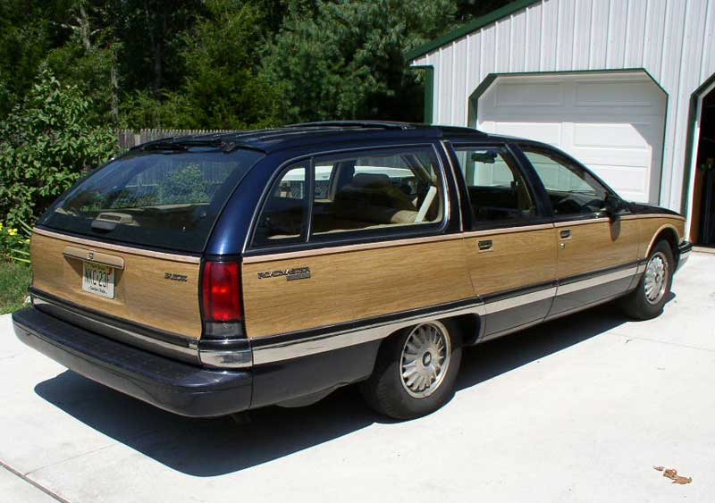
A few months later, I saw another nice one for sale in a nearby town for only $1,500. I bought it and parked it in the garage (next page).
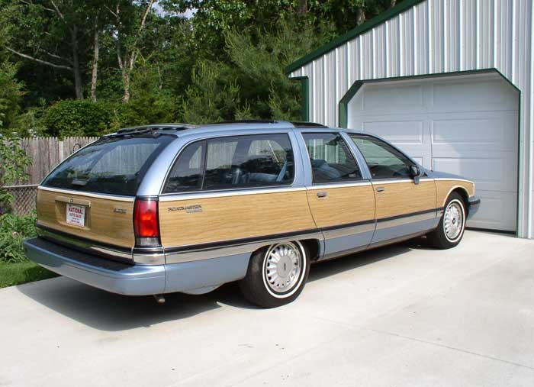
After four years, I decided that it was time to register the other wagon but it didn't happen! I discovered another Roadmaster wagon on eBay located just across the Delaware River in Wilmington. It was our favorite color, metallic burgundy and had a burgundy leather interior. Best of all, the car had only 49,000 miles on the tachometer and was in like-new condition! I sold number 1 and 2 wagons for enough money to pay for number 3!
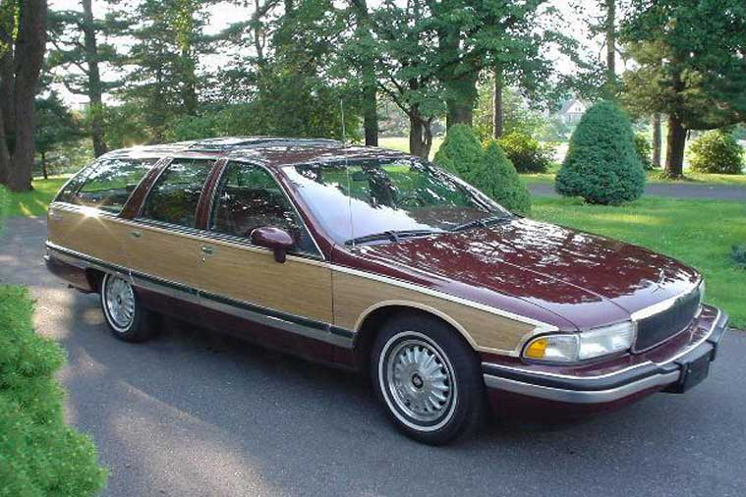
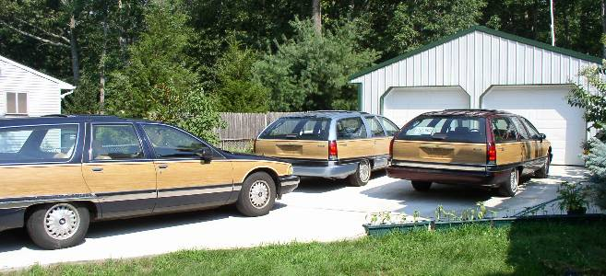
One year later, we sold that car and bought another one on eBay. It was also burgundy, in great condition and had low mileage, but there were features that the previous wagons didn't have. These included the famed LT-1 injected engine that also powered the Corvette. Some claim that it is the best engine that GM ever produced. Another feature was a complete heavy-duty towing package with extra oil and water-cooling plus load-leveling. We bought it in 2007 and in 2021, it is still in the garage with collector-car tags, gaining value.
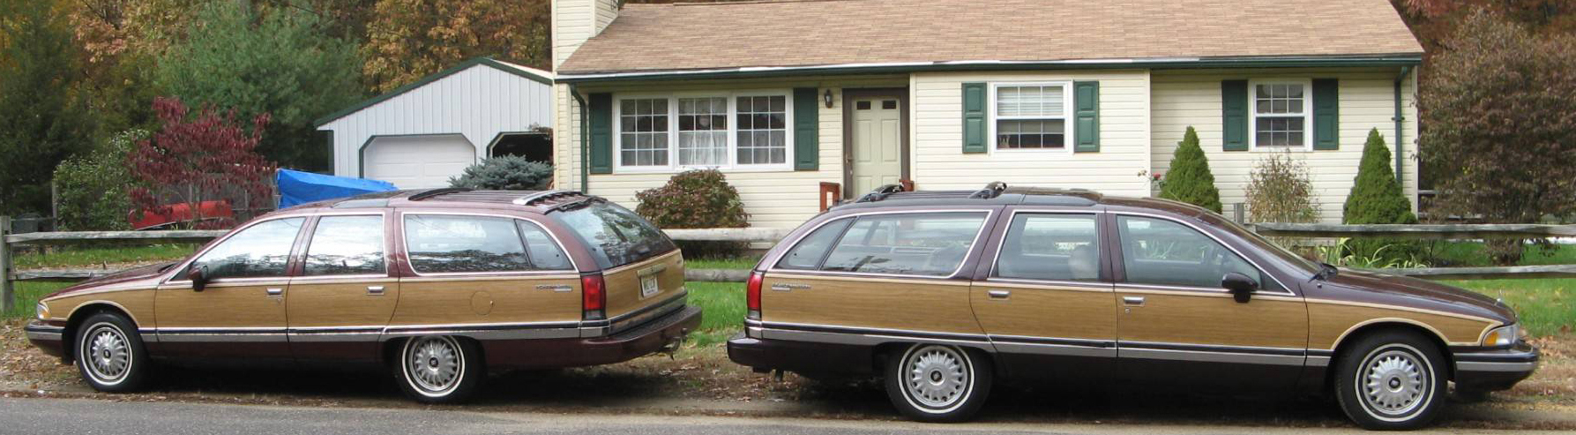
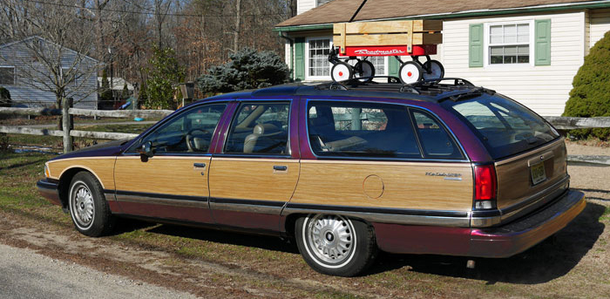
I actually bought a fifth Roadmaster brand new for just $50. It wasn’t a woody, but I fixed that little detail. The car is always a hit at parades, towing a sailboat!
1975 Mercedes 450 SLC
In the late 70s when our children were attending Black Forest Academy in Germany, we walked past a used car dealership near the school and Verna paused to admire one of the cars. "That is a cute car, what kind is it?" she asked. I replied that it was a Mercedes SLC and, without much forethought, I added, "When we retire, I will buy you one." From that time on, every time Verna spotted an SLC on the road, she asked, "Is that mine?"
Twenty-five years later, we did retire, and although Verna only expected me to buy her a Matchbox or diecast Mercedes, I kept thinking about my promise. I reasoned that there must be a 25-30 year-old SLC somewhere that needed TLC and wouldn't cost too much. I kept checking eBay and newspapers, but most were too expensive or too far away. I found a really nice Burgundy SLC on eBay, but the reserve was too high so I didn't bid on it. One day while Verna was packing for meetings in Connecticut, I checked eBay and saw that the owner had re-listed it with a "Buy-it-Now" price well below it's book value. I drew $6,000 from my retirement account and bought it. I didn't tell Verna, but stopped on our way to Connecticut. She asked where I was going and I just said, "Wait and see!" The owner opened the garage door and I said, "I kept my promise!"

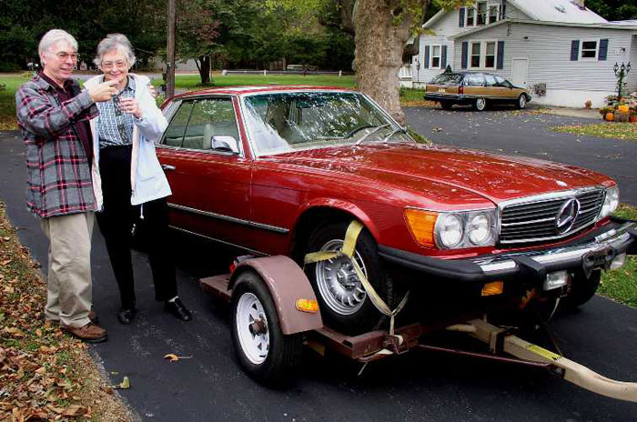

Verna's SLC had all the extras: electric sunroof, power windows, AC, Automatic und a 4,5 litre V8. It had been garaged all it's life and had only been driven 91,000 miles. The burgundy paint and chrome shone like new. Verna seemed happy when I handed her the keys, but she always preferred to drive the Buick. After a year, we sold the Mercedes for $2,000 profit and invested the money in a cement driveway. We can honestly tell people, "Verna's Mercedes is in the driveway."
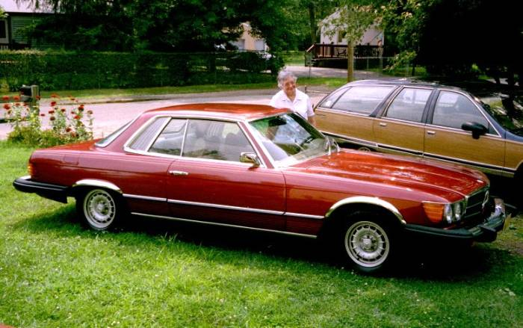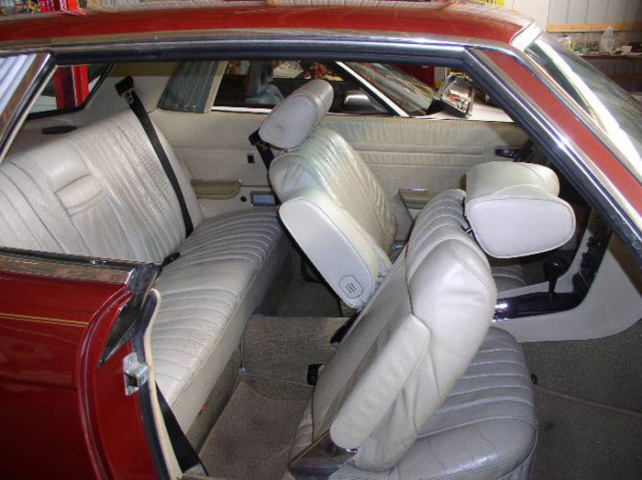
Daily Drivers
From 2002 through 2009, the Roadmaster Estate Wagon was our daily driver. Because these behemoths of the highway were much sought after and therefore getting scarce, I decided to get a second small car to use for most travel. I always preferred rear-wheel-drive, but most small cars now have front-wheel-drive. We once had a '91 Buick Century with the 3.8 liter six-cylinder engine and liked it, so I began to search for one of those.
I wound up with a 1991 4-cylinder Honda Accord. It was listed on eBay and the seller said the transmission was defective, but otherwise fine. It was located nearby, so I went to check it out. It started immediately and I could drive it forward and backward with no problem, so I asked about the defect. The owner said "The warning light comes on and that is all I know. My mother has been driving it like that for weeks." I bid on the car and got it for $1200.
Ever since solder containing lead was outlawed, many cars have problems with sensors, modules and relays. I removed the transmission sensor, took it apart and re-soldered all the connections. The light stayed off and the car performed like new!
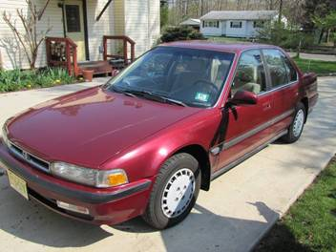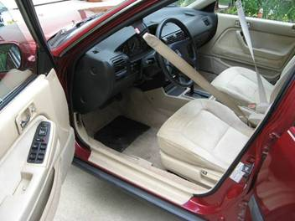
After a year of trouble-free service, the Honda developed a valve tap. I removed the valve cover to adjust the tappets and found that the threads were stripped on one of the valve stems. I really wanted a V6 engine, so I offered the Honda on Craigslist "as is" for what we paid a year earlier. Within an hour, we got over 20 calls for the car! When we awoke at 6:00 the next morning, a couple from Pennsylvania was parked in our driveway with cash!
1902 Buick Skylark V6
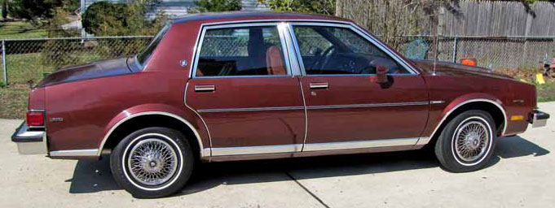
I began looking once again for a V-6 Buick Century, but like before, I found something else. An impeccable '82 Buick Skylark came up that was about to finish its auction with no bids. The seller claimed that it had only been driven 24,000 miles and because it is very similar to the Century and had the V-6 engine, I bid in the last minute and got it for $2,200!
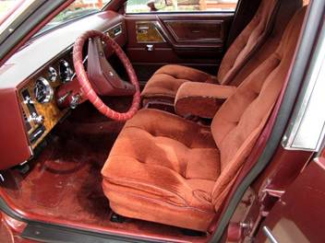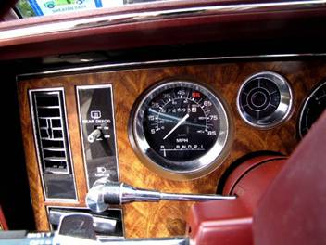
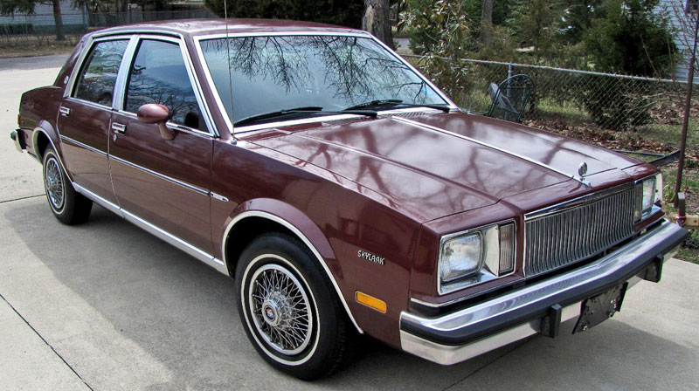
There was one big problem with my acquisition, however. This car was much too nice to use as a daily driver, especially in winter! I sold the Skylark for a good profit before winter set in. That car was not going to see any salt on my watch!
Buick Century V6
We had owned a '91 (next page left) and were very pleased with it, so I was glad to find a '92 Century (next page right) for only $1200. We drove it about 5,000 miles and then sold it for what we had paid to buy an extremely nice 1995 Century "Sport" pictured next.

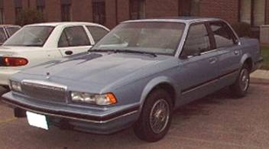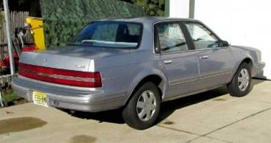
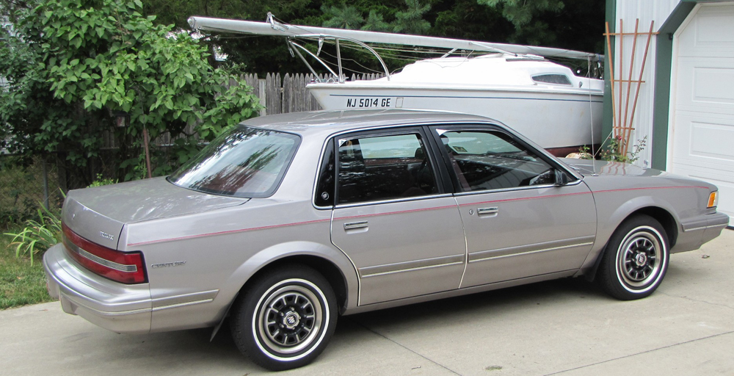
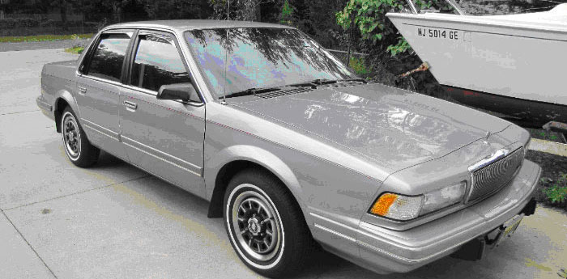
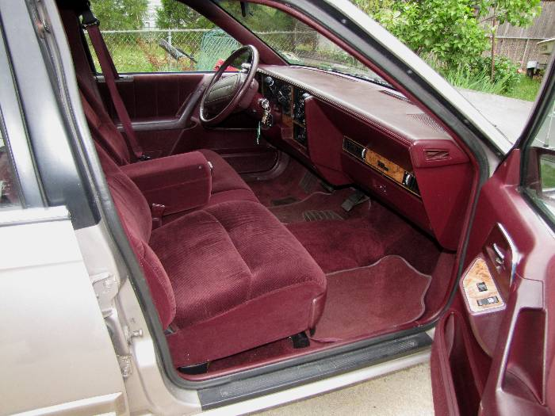
Our First Mercury Grand Marquis
The last US cars that were sold with rear-wheel-drive were the Ford Crown Victoria and it's luxurious cousin, the Mercury Grand Marquis. The police and taxi companies bought most of these cars because they were comfortable, robust and very dependable. When Ford decided to halt production in 2010, pre-owned models in good condition were soon selling for high prices, often to taxi owners.
When our '95 Buick Century needed repairs that I couldn't do myself, I decided to start looking for a Crown Victoria or Grand Marquis. One Sunday, I noticed that an elderly lady in our church was driving her brother's 2011 Grand Marquis (the final year was 2010 but a couple of hundred leftovers were sold in 2011). She said that her brother could no longer drive and he sold her the car. He had also sold her his 2003 Marquis when he bought the 2011. I knew the car to be in pristine condition, so I asked how much she was asking for it. She replied, "$5,000".
That price was reasonable, but we had only gotten $1200 for the Century and couldn't afford the car. On August 23, 2013, I bought a white 1995 Grand Marquis with 120,000 miles for $1,400. I installed new shocks, serpentine belt, idler and tensioner pullys, ignition cables and sparkplugs, bringing our investment to $1758.78. It served us well and we were very happy with it -- for three and a half months and 8,000 miles.
On December 5, 2013, Verna was involved in her first accident. She had been driving 55 years without even a traffic ticket, but while driving to the Garden Club Christmas dinner at the Scotland Run Golf Course, she was hit by a woman who ran a stop sign and blinking red light. Verna had been looking forward to eating baked salmon with the girls, but had a hot dog with me instead.
After the cars hit in the middle of the intersection, Verna's car did a quarter turn to the right and wound up on the wrong side of Grant Ave. The other car did a 180 degree spin and landed in the trees on the opposite side of the road. Verna can't remember the crash but remembers seeing it coming and thinking, "This is going to be bad!"
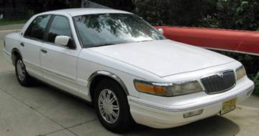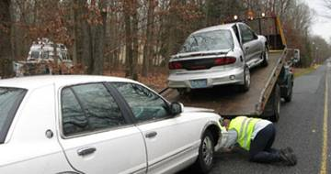
Both cars were totaled. Ours would have been fixable but the airbags deployed and replacement of these would have cost more than the car was worth.
Speaking of airbags, a police inspector and the ambulance medic both warned Verna, "You need to throw all your clothes in the washer and take a complete shower before putting on fresh clothes. The stuff in those airbags causes cancer." A policeman then told her that she should sit in our car until I arrived! Airbags save your life and then kill you!
We spent 3 1/2 hours in the ER where Verna got a tetanus shot, her leg bandaged and cat scans on her head and neck. The results came back favorable. She was sore and had black and blue marks from the seat belts and airbags but nothing serious. We thanked God his for protection. A week later, we also thanked him for his provision. The other driver's insurance paid us $3,734, so we could go car shopping again!
A Second Mercury Grand Marquis
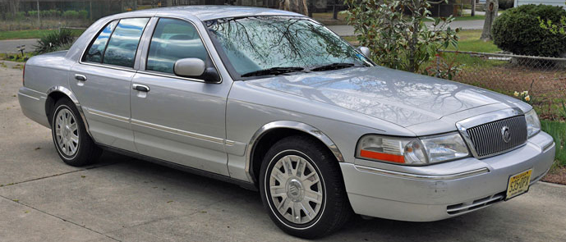
I saw our friend in church the following day and told her, "It was good that we didn't buy your car because the one we bought was just totaled in an accident. She surprised me by saying that her 2003 Mercury was still in the garage. She had not sold it! I asked if she had come down on the price and she said she would sell it for $2,750.
It was the first day of winter in 2013, shortly before Christmas, when we bought "Silver Bird". The car had been driven only 81,000 easy miles in ten years. Because the owner spent winters in Florida, it had seen very little snow. In the next five years we drove it 50,000 miles without a complaint, but then, Verna was involved in her second accident!
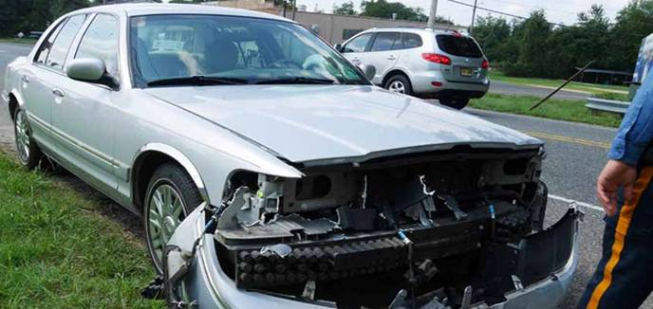
At an All-Way Stop, a teenage girl barreled into the intersection without stopping. She saw our car and drove into the opposing traffic lane trying to avoid it. She struck the end of our car's bumper, peeling the plastic skin off (no frontal impact whatsoever and no airbags deployed!). The lights and grille were also broken, but the rest of the car was undamaged. After hitting our car, the other driver tried to correct her mother's Buick and flipped it over on its side. Fortunately, no one was injured.!
Because both drivers claimed to have stopped before entering the intersection, the New Jersey "No Fault" law kicked in. That means neither driver gets remuneration for damages unless they hire a lawyer. The other car was totaled, but I fixed our car for less than what a lawyer would have charged. I bought a donor car, took the parts that I needed and sold $600 worth of other parts before junking what was left.
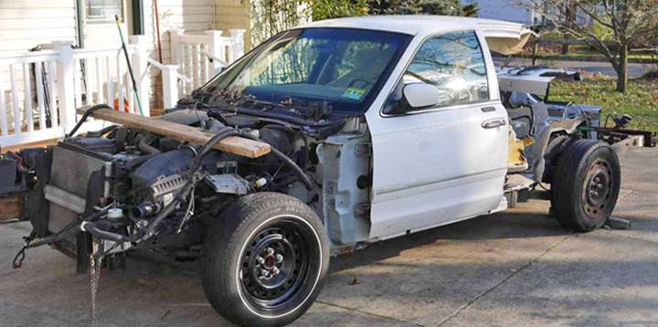
One week later, we were traveling to a church function when I hit a deer! All the parts that I had just installed were damaged again. This time I bought new parts from Amazon for a little over $500!
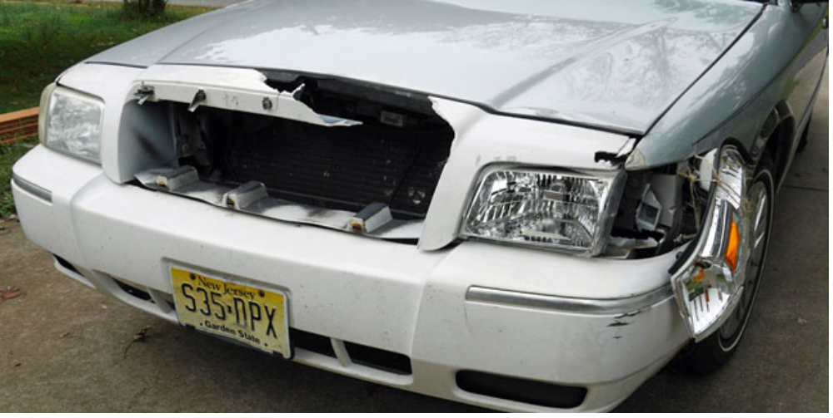
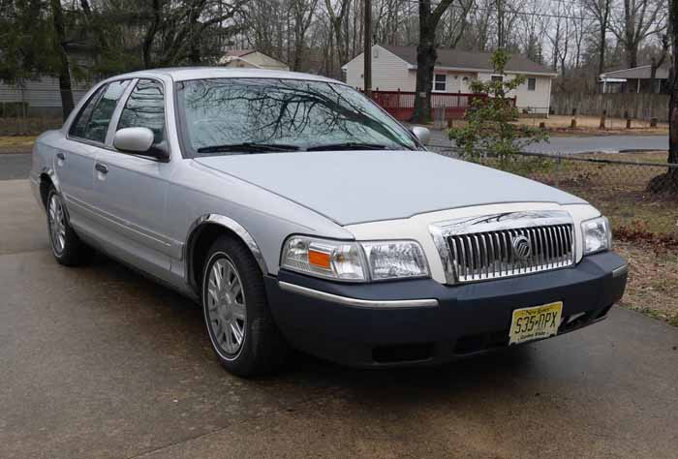ArAround that time, the lady who sold us "Silver Bird" told us that she was no longer allowed to drive. Did I want the 2011 Marquis? It had only 80.000 miles on it.
2011 models were selling for top Dollars and, again, we couldn't afford to pay even her generously reduced offer. Besides, the Silver Bird was serving us well and after two accidents and repair jobs, I had gotten rather attached to it!
Two years later, our "Silver Bird" had accumulated 160,000 miles, so I started checking ads for another low-mileage Marquis that we could afford. I watched several nice ones sell for a lot of money and a few needing work or with high mileage that also sold for far too much.
I bid on a 2008 model that was "in perfect condition with low mileage" and was surprised when I got it. I called the seller to arrange for paying and pick up, but he said that it had suddenly developed a serious engine problem and he couldn't complete the transaction. I later discovered that the car was on eBay again with the same photos and description, so I did some research. I found that this guy had "sold" the same car three times already! Go figure!
A Third Mercury Grand Marquis
A few weeks later, I saw a Marquis on eBay located just across the Delaware River. The seller claimed that the car had "spent all its life in Las Vegas, had only 71,000 miles and had never seen salt or snow". Probably because it looked too good to be true and came from “sin city”, no one bid on it.
I wrote a note to the seller just before the auction ended, saying that I was very interested. If no one bought the car, I would like to come and see it. If all was okay I would pay cash. I was surprised when he replied, "I am leaving on a longer business trip tomorrow but if you come in the morning, I will be here." He gave me directions to his home. Verna and I drove over and were amazed that every claim he had made was true. He inherited the car from his Aunt, flew out to Vegas and drove it back. He liked the car so much that he intended to keep it, but then pointed to his garage and said, "I don't have room in the garage and it would be a shame for this car to stand outside in winter." I looked in the garage and gasped. A Mercedes, a Porsche and a big Harley Davidson were staring back at me! We got the car for $4000.
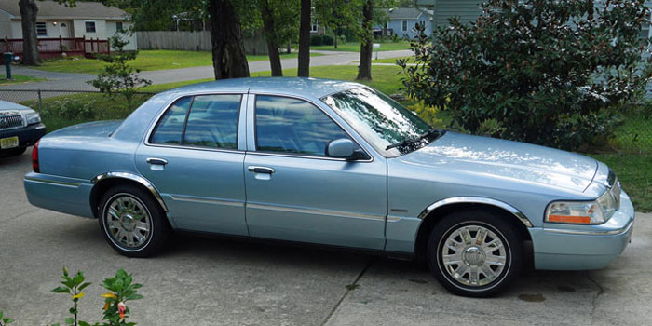
In September, 2020, a single father who lives across the street was surprised and elated to receive a special gift! We gave him the "Silver Bird" after his older Honda gave up the ghost. He is trying to raise two young boys (their mother left them) and working, but is really struggling financially.
God has blessed us with this lovely "Bluebird" and as I mentioned in the beginning, after 13 retirement vehicles, we still have a profit of over $600 after buying and selling 12 vehicles - plus a classic “woody” in the garage to keep “Bluebird” company!
I thought that the Bluebird would be our final retirement car and we still have it, but I saw another Marquis of the same year with only 70,000 miles on the tacho for $4,000 and bought it. I had enough money in a checking account and since our generous President has been borrowing and giving away trillions, our currency is losing around 5% per year of its value. A Grand Marquis with low mileage gains 20% in value annually, so it is a better way to save.
A Fourth Mercury Grand Marquis
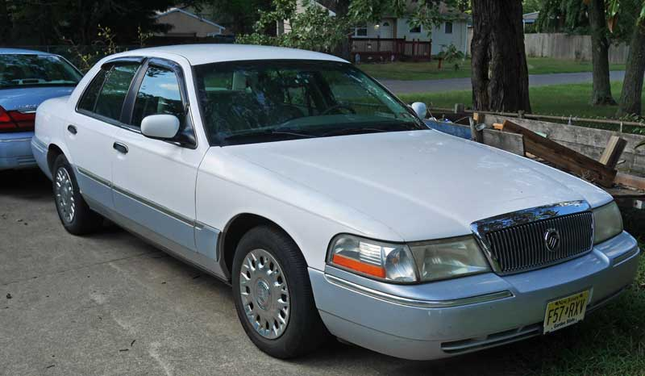
This car has the leather interior and a two-tone paint package. Shortly after this purchase, our neighbor bought a pickup and returned the Silver Bird, so I now have three 2003 Grand Marquis sitting in our driveway and a 1004 Roadmaster “Woody” in the garage!



